T-bert (Q*bert)

Game Design Document <Current Version>

Team 13

Written by <Kristijan, Vivian, Alex, Danny, & Yichen>

<7/20/22>

<Copyright info, ex. All Work Copyright ©2022>

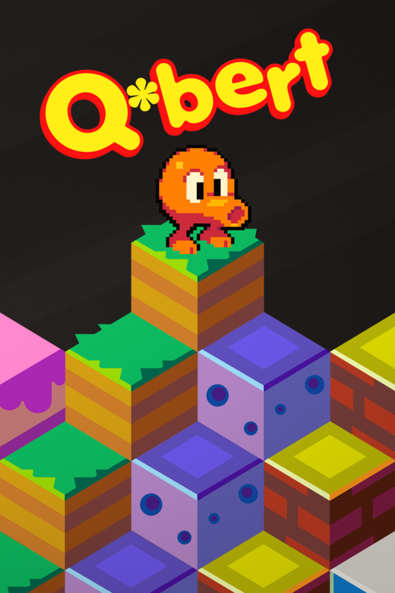

# *Overview*

## **Summary**

### Brief Description

<Q*bert is found in the past, located in a pre-historic jungle. Things seem slightly different, the enemies that followed him, and Q*bert himself, are all pre-historic. With the unknown surrounding him, Q*bert must scale the many mountains and tiles to find a way home, but surprise, things are not as they seem. Q*bert must kill the dinosaur that suddenly took his place atop the mountain, and team up with his enemies to do so.>

## **Design Pillars**

### <Accumulate points>

<By completing levels, stomping on enemies, and stepping on tiles, as T-bert you traverse the levels gaining more points as you go.>

### <Cover all the tiles>

<Your ultimate goal is to cover every single tile and reach the next round, and eventually level.>

### <Avoid enemies>

<Each enemy is out to get you, only one can be killed in a strategic manner, thus avoiding most of them is your only option.>

## **What makes the original fun and popular?**

1. With addictive design pillars, the player wants to keep on stepping on the tiles as it creates a satisfying sound and provides points
2. Point system leaves the player always wanting that next high score
3. Cool and funky character, popular with the younger audience
4. Fun gameplay elements
5. Three lives create tension for the player

## **Theme/Setting/Genre**

<In this puzzle platformer, the player is located on a mountaintop, filled with cubed tiles in a pre-historic setting dominated by dinosaurs, and apparently Q*bert.>

## **Main Objective**

<Change as many blocks as possible to the instructed color and score the most points without dying.>

## **Target Audience**

<Fans of the original looking for something new in the fan-favorite Q*bert. The game is also perfect for any casual or expert player looking for a puzzle platformer challenge.>

# 

# *Gameplay*

## **Victory Conditions**

<The player's objective is to cover every tile on the tile pyramid, they can rack up points, and are not restricted by time.>

## **Core Game Loop**

<The player will constantly be attempting to cover the tile pyramid, each time new enemies show up attempting to mess with the T-bert’s progress.>

## **Mechanics**

## **Level One:**

<Jump on a tile to change its color to the desired color.>

<Purple Frog jumps down, attempting to block the path of T-bert.>

<Dodo Bird reverts progress.>

<Cavebert follows the player, hunting it, but does not revert tiles.>

<Cannot jump on the purple frog or Cavebert, can jump on the dodo bird to stop its terror.>

**Level Two:**

<Moving disc to assist and bring the player up to predetermined locations.>

<Spider crawls on the side of the tiles, trying to kill T-bert>

**Obstacles**

<Enemies: Purple Frog, Dodo Bird [killable], Cavebert.>

<Over 1 block heightened tiles.>

<No borders preventing walking off the tile space and falling into the void.>

**Resources**

<The player has three lives.>

<Can use placed Pterodactyls on the sides to reach the top of the mountain quickly and kill Cavebert.>

**Rules**

<Can jump one tile at a time.>

<Can only jump diagonally and either in the up or down direction.>

<With enough lives, you respawn back at your last position after death.>

<Can’t kill Purple Frog or Cavebert.>

<T-bert “gets angry” after getting hit.>

<Can jump one tile at a time.>

<Once you run out of all three lives, your progress resets back to the start.>

# 

# *Characters*

**Characters**

## **T-bert**

<The main player character with a whole new design created for the game.>

<Can jump around and change the status of tiles to complete, and jump on certain enemies.>

## **Purple Frog**

<Jumps around trying to block T-bert’s path, cannot be jumped on.>

<Can damage T-bert.>

## **Dodo Bird**

<Hops around reverting the progress of the tiles, can be jumped on in order to be stopped.>

<Can damage T-bert.>

## **Cavebert**

<Moves by chasing after T-bert, can be killed by tricking it with the discs.>

<Appears as a boulder rolling to the bottom of the mountain, pops open revealing Cavebert.>

<Can damage T-bert.>

## **Pterodactyls**

<Helps bring T-bert to the top of the mountain by flying him up in times of need.>

# 

# *Technical*

## **Screens**

### Title Screen

<T-bert logo center screen, with a play button, and any recent high score.>

### Gameplay Screen

<Mountain of tiles in a pyramid shape, T-bert can be found ready to go at the top above the sprawling jungle below.>

### Game Over Screen

<Session score, the session round reached, high score, and Menu Menu button.>

## **Controls**

<WASD to move.>

<W: move up and to the right>

<A: move up and to the left>

<S: move down and to the left>

<D: move down and to the right>

<The controls cannot be configured and are designed only for keyboard support.>

# 

# *Art & Audio*

**Visual Style**

<2D.>  
<Animated characters.>

<Warm saturated colors.>

<Prehistoric themed.>

<Background: Blue sky of clouds with a mountain, jungle trees.>

<UI Elements: Points, current round, life count, current goal (what color block you need).>

**Audio Design**

<16-bit prehistoric, funky, retro background gameplay music, two dynamics of “fighting parties”. Make the player feel like they’re on an adventure in the jungle with dinosaur roars and Aztec instruments such as bongos.>

<Menu music with a similar theme as above.>

<Somber game over music.>

<Sound effects: T-bert jump and roar, Purple Frog jump, Cavebert jump and fall, Dodo Bird jump and death, button sound, T-bert falling into the void, success for beating a level, losing a life, moving Pterodactyl.>

**Voice Acting**

<Higher pitched roar for T-bert when swearing after being hit.>

# 

# *Team Overview*

## **Team #13**

#### **<Vivian Zhao>**

* <Programmer>

#### **<Yichen Dai>**

* <Programmer>

#### **<Alex Chow>**

* <Artist>

#### **<Danny Yu>**

* <Artist>

#### **<Kristijan Zvonarek>**

* <Sound Designer>
* <Producer>

# 

# *Development Notes*

**Post Play on Arcade:**

<The controls were confusing and stiff.>

<Respawn at the last location.>

<No background music, will be added.>

<The snake egg is purple.>

<Implement three-fingered keyboard control system, focus on not being strict, and make it feel like a joystick.>

<Dinosaur-themed (Q*bert has a fin, prehistoric jungle-themed zone, and tiles).>